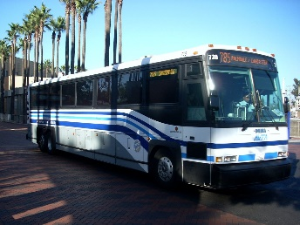
New York City Bus Trip (on your own day)
Date: Thursday, November 30, 2023
Departs: St. Joseph the Worker Church Parking Lot at 8:30 am promptly
(Please arrive 10 – 15 minutes before departure.)
Arrives: Rockefeller Center between 10:30 am and 11:00 am
Departs: Rockefeller Center at 6:00 pm promptly
(Please arrive 10 minutes before departure.)
Arrives: St. Joseph the Worker Church Parking Lot between 8:00 pm and 8:30 pm
Bus Ticket: $45.00 per person
Make checks payable to: St. Joseph the Worker Women’s Guild. Mail your check with the completed form below to:
Donna Gasper, 8404 Countryside Lane, Fogelsville, PA 18051.
You will receive an email confirmation once your check has been received.
The bus holds 55 passengers, so it will be first come first serve.
Thank you,
Donna Gasper
484-241-1011

If you are paying for more than one person, please complete the information below for each member of your party.
Name __________________________________________ Phone: ____________________
Email: __________________________________________
Emergency Contact
Name __________________________________________ Phone: ____________________

Name __________________________________________ Phone: ____________________
Email: __________________________________________
Emergency Contact
Name: __________________________________________ Phone: ____________________

