First Reconciliation
2026 Important Dates and Information
St. Joseph the Worker

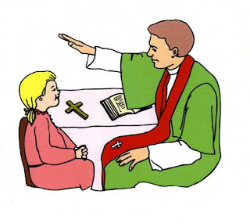
Saturday February 14, 2026:
Last Names A-L: 10:00 AM
Last Names M-Z: 11:30 AM

A brief prayer service will be held prior to the children receiving the Sacrament of Reconciliation. Students will be seated together in the front of the church with their teachers. Following the prayer service, teachers will guide the children to one of the priest hearing confessions. After completing their confession, each child will proceed to the front of the church to complete their penance.

Children preparing for their First Reconciliation are asked to dress in their “Sunday best”.

A onetime Sacramental fee of $35.00. covers both First Reconciliation and First Eucharist. Payment may be made online using the link below, or by check and made payable to St. Joseph the Worker.
https://www.osvhub.com/stjwchurch/forms/2026-sacramental-fee

Please review the form for Confession and the Act of Contrition below:

*O my God, I am heartily sorry for having offended Thee and I detest all my sins because of Thy just punishments, but most of all because they offend Thee, my God, who art all good and deserving of all my love. I firmly resolve with the help of Thy Grace to sin no more and to avoid the near occasion of sin. Amen

