First Communion is Saturday, May 2, 2026
10:30AM

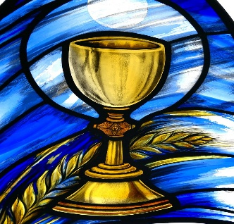

Due to the number of students, families are asked to limit the number of guest to 12

The best preparation for the Eucharist is taking your child to Mass regularly and helping your child understand what Mass is all about.

The Eucharist is the greatest gift that Jesus gave to us – the gift of Himself.
The Catechism of the Catholic Church states that, “the principle fruit to receiving the Eucharist in Holy Communion is an intimate union with Christ Jesus.”

REHEARSAL:

The rehearsal date is Thursday, April 30, 2026 6:00-7:30, PM FOR SCHOOL AND Family Faith Formation Please bring your child’s banner to the rehearsal.

Students are to report to the Parish Center. Parents need not attend. Students will be dismissed from the Parish Center.

WHAT TO WEAR: Girls wear white dresses, with white shoes, white anklets or white tights. Please no purses, gloves, jewelry, or flowers for the Mass. Flowers may be worn in the hair as part of a veil.

Boys wear a dark suit, or dark sports coat and slacks with a tie. Dress shoes should be worn (no sneakers please).

Students should wear their First Communion clothes to Mass on Sunday, May 3rd.

BANNERS:

Each student is asked to make a banner. You will be given a piece of stiffened felt along with suggested Eucharist symbols. Each family should design their banner. The child’s first name should be on the banner with a symbol of the Eucharist. You may use markers, felt letters, and fabric paint to create your banner. NO GLITTER, PLEASE. The banners will be hung in the Church as a reminder to our parish family to support our students in prayer. You may take your banner home with you following the Mass.

ALTAR SERVERS: If there is an older sibling who is an altar server and would like to serve, please notify the Family Faith Formation office with a note as soon as possible.

PICTURES:

Lehigh Valley Photo Group will be available to take your child’s Communion picture. The dates will be Monday April 27, or Tuesday April 28 2023. Please look for a Sign Up Genius by email at a later day. A complimentary group photo will be taken at the end of Mass.

