Wedding Guidelines

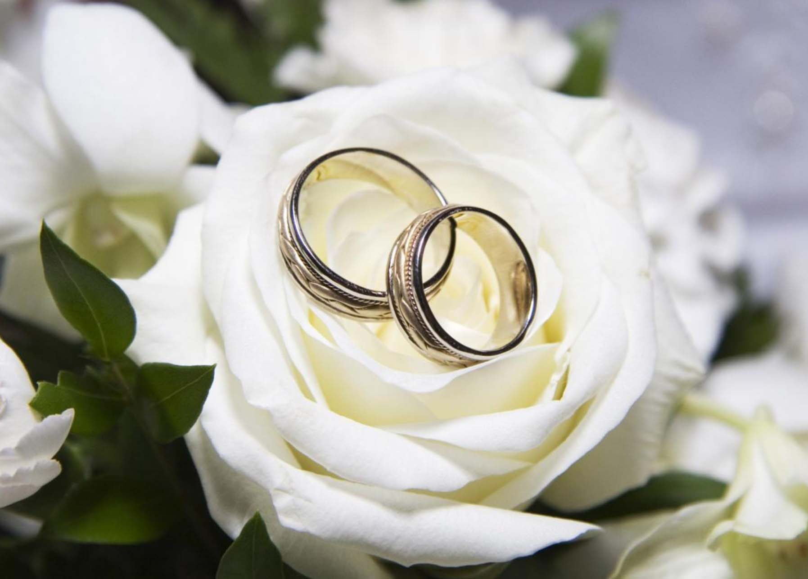

St. Joseph the Worker

Roman Catholic Church

1879 Applewood Drive

Orefield, Pennsylvania
www.stjwchurch.org

610-395-2876

Wedding Guidelines
for
Saint Joseph the Worker
Roman Catholic Church

Your wedding at Saint Joseph the Worker will be one of the most important days in your life. Your pastor and deacons realize this and they stand ready to help you make your wedding day reverent and beautiful and your marriage fruitful and lasting. This is the primary purpose for these guidelines.

Please read these guidelines carefully. They will help you in understanding canonical, civil, diocesan, and parish requirements for your wedding and marriage. This booklet will also help you plan your wedding liturgy as a couple intent upon receiving God’s special blessing in a ceremony surrounded with dignity and grace.

Contacting Your Parish

Please call the Parish Office (610-395-2876) during business hours as soon as you have decided the approximate date of your wedding. While the parish secretary may possibly be able to tell you whether or not the date and time you are considering is currently open, the date and time can only be reserved and set after the date has been discussed with the pastor and approved by him. This includes those weddings also performed by our deacons.
While every effort will be made to accommodate you, we cannot promise that the date and time you have chosen will be available since couples have been reserving dates as far as two years in advance.
Finally, we strongly recommend that you do not make formal arrangements for a reception hall (contract, down payment, etc.) until after you have spoken with the parish. We would not want to see you caught in the embarrassing situation of having made arrangements for your reception and, afterwards, finding out that the church is not available.

Canonical (Church Law) and
Civil (State Law) Requirements

Couples who plan to marry within the Catholic Church must meet the following canonical and civil requirements:
I Catholics:
The Catholic party must present the following to the priest:
- A recent Baptismal Certificate (issued within six months from the date of the wedding). You can get a certificate from the church of your baptism by calling or writing to the parish office. Please give them the date of your baptism, or the date of your birth if your date of baptism is unknown.
- A Confirmation Certificate, or notation affixed to the baptismal certificate stating that you were confirmed and on what date and in what parish.

II Non-Catholics:
The non-Catholic party who is a baptized Christian must present the following to the priest:
- A Baptismal Certificate. If one is not available, an affidavit of baptism must be given. This affidavit can be sworn to by parents, close relatives, or other trustworthy witnesses having knowledge of the non-Catholic’s baptism.

III All Parties:
All parties must present the following to the priest:
- The Marriage Preparation Certificate (or Engaged Encounter Certificate) attesting that you have completed this diocesan required course.
- A Declaration of Nullity is necessary if either party had been previously married, and if the former spouse is still living. This is necessary regardless of where the former marriage was celebrated.
- A Death Certificate for any deceased former spouses of either party to the proposed wedding.
- Parent’s Permission Letter, when a party to the proposed marriage is less than 21 years of age.
- Any marriage between a Catholic and non-Catholic requires a Dispensation. The priest or deacon handling your marriage will inform you of this requirement and will apply for the dispensations needed.
- At the wedding rehearsal the couple must present their Marriage License, a civil document to be obtained at the County Court House. If one of the parties is under 18 years of age, that person’s parents must accompany the minor to the Courthouse, since signed affidavits will not be honored. The marriage license, once granted, is valid for 60 days. In Pennsylvania this license consists of three separate parts. Please present the entire license to the priest at the rehearsal.

Diocesan Requirements

The Diocese of Allentown has established a policy to help couples prepare for the celebration of the Sacrament of Marriage. It is based on Canon Law as well as the experience of many years of preparing couples for marriage. This Marriage Preparation Policy has a few important points of which all couples need to be aware:

- Couples must notify the parish of their intent to marry at least six months prior to the date of the wedding. Practically, it is usually much earlier that a couple will notify the parish, due to the availability of reception halls, etc.. Nevertheless, contact must be made at least six months in advance.
(N.B. please refer to parish policy in regards to parish registration prior to establishing a date for a wedding)
- Couples meet with the priest/deacon on an average of three times before the wedding. This is to ensure that all paperwork is completed, that all permissions are received, and that all the details concerning the actual liturgical celebration are completed. These meetings are also an opportunity for the priest to review with the couple the Church’s teachings on marriage, sexuality, and family.
- You will also be asked to participate in the FOCCUS Inventory which is done online. Details of this “test” will be discussed with you by the priest or deacon.
- All couples preparing for marriage must attend one of the diocesan sponsored preparation programs for marriage.
Marriage Preparation Program - Couples register for and complete the online program at CatholicMarriagePrep.com. In addition to working through the course content, you will receive the guidance and facilitation of a certified instructor couple, who you will be paired with upon registration. The online course takes between three and twelve weeks to complete, depending on the couple.
The program fulfills the diocesan requirement for a preparation program. You will receive information on this from the priest or deacon making arrangements for your wedding. You may go online at www.allentowndiocese.org/marriageprep. There you will be able to register for the Marriage Preparation Program on the diocesan website.

Parish Requirements

Listed below are the parish requirements for Saint Joseph the Worker. We would ask that you take special note of these requirements and that you observe them fully. They are designed to help make your wedding day the most beautiful day possible.

I Parish Registration
In order to be married at Saint Joseph the Worker, at least one party to the marriage must be a registered practicing member. Registration can either be on your own or through your parents if you are still living at home. If you live outside our Diocese you will need a letter from your parish granting permission to marry here.

II Guest Priests
We welcome you to invite a priest/deacon (who must be in good standing with the Church) relative or friend to our church to celebrate your wedding. The guest priest will be responsible for the paperwork, marriage preparation, and the rehearsal. Please be advised that the offering you give to the Church, does not go to any priest, but helps defray the cost for the Church. It will be your responsibility, if you so choose, to offer something to the priest that you invite to do your wedding in addition to the stipend that you give to our Church. Please make the Priest or Deacon at Saint Joseph the Worker aware that you wish to invite another priest. All visiting priests or deacons must submit a “suitability for ministry” form at least two weeks prior to the marriage.

III Wedding Times
Weddings at our church are normally celebrated at 10:00 AM, 12:00 PM, and 2:00 PM on Saturdays when weddings are permissible and possible. Weddings cannot be celebrated later than 2:00 PM because of the Sacrament of Reconciliation and weekend Liturgies. Exceptions to these times or this day of the week can be made only through the priest or deacon who will be celebrating your wedding.

IV Rehearsal Times
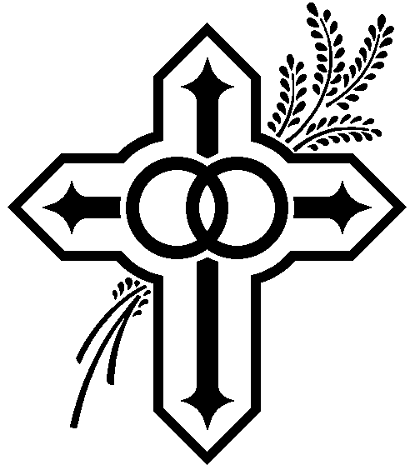
The rehearsal for your wedding normally is held the day before your wedding. The time should be set with the priest or deacon who is celebrating your wedding. Normally rehearsals are scheduled for late afternoon. At the rehearsal the civil marriage license, the envelopes containing the offerings for the wedding, and other items used during the wedding should be presented to the priest/deacon conducting the rehearsal. Please be prompt for the rehearsal and dressed appropriately. We would encourage you to invite only those people in the wedding party and those who are participating in the ceremony in some way.

V Wedding Offerings
Minimum offerings for weddings celebrated at Saint Joseph the Worker are to be made according to the following schedule and in the separate envelopes provided by the Church for each specific offering. If you wish to give more than the minimum please feel welcome to do so. If possible we ask that you use cash in filling the envelopes:

a. Church Offering $225
b. Organist $150

c. Soloist/Cantor $100
d. Altar Servers $20 (please use 2 $10 bills)
e. Rehearsal $50
f. Celebrant Offering $75

If someone other than the parish organist or cantor is engaged to provide music for the Mass or ceremony, the couple should pay their fees directly and not include them with those given to the priest/deacon at the rehearsal. It is highly desirable that our own organist be utilized since they are familiar with the instrument. If the organist needs to practice with a guest cantor an additional charge may be incurred.

VI Wedding Flowers
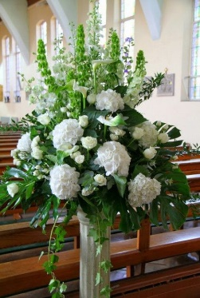
Flowers are an important part of the joyful decorations for a wedding. However, when flowers are placed in the Church sanctuary they become much more than decorations. There, they become an offering from the couple to the Lord. Since it would be unusual to offer flowers to the Lord for an hour and then take them away to be used elsewhere, we ask you to plan your flower arrangements in such a way that those placed in the sanctuary may remain there. Arrangements should be an appropriate size to fit the size of the sanctuary/Church.

The law of the Church also prohibits flowers and any sort of decoration in the Church during the Lenten season. Arrangements of flowers for weddings are the responsibility of the marriage couple.

VII Wedding Photographs
Photographs and video recordings may be taken during your wedding ceremony. We do expect, however, that the photographer/videographer take care not to become a source of distraction during the ceremony. For that reason we ask that flash photography not be used if at all possible. If it must be used it should be kept to an absolute minimum, being utilized only at the entrance and recessional of the wedding party. Similarly, we ask that no floodlights be used, nor should the photographers enter the sanctuary area.

Due to other church services, and perhaps other weddings on the same day, photographs taken in the church may not exceed past 3:30 PM (for a 2:00 PM Wedding) or thirty minutes after your wedding ceremony. Photographs may be taken in the Church sanctuary as long as all parties act respectfully.

We ask you to please inform your photographer/videographer of the various points of these guidelines pertaining to photography/videography in the Church. Please emphasize the one half-hour limit for photographs after the ceremony. Please inform the photographer/videographer to stop in the sacristy before the ceremony to meet the priest or deacon who will also discuss the pertinent points of the policy with them if necessary.

VIII Receiving (Reception) Lines
We strongly discourage the couple from choosing to have a receiving line for their guests in the Church vestibule immediately after the ceremony. Our reasons follow:

1. The receiving line takes a great deal of time and can very easily take up time allotted for photographs. The scheduling of other weddings and of confession makes it impossible to extend that time.
2. The proper place for a receiving line is at the wedding reception which follows the ceremony. In fact, the dinner is called a reception because it is the place where you receive your guests individually, courteously offering them an opportunity to express their good wishes and to present you with a gift.

IX Rice, Confetti, Birdseed, etc.
Due to insurance regulations, wedding couples are asked to tell their guests not to throw rice, confetti, birdseed, flower petals or similar substances either inside or outside the Church. This practice always makes a mess and it causes hazardous walking conditions, especially when weather is inclement.

X Wedding (Unity) Candle
Although the use of the “wedding/unity candle” has never been prescribed in the wedding liturgy, it seems that some still wish to have this. It cannot be considered an option since it was never prescribed for use within wedding liturgies. The symbolism of the “wedding/unity candle” is very poor; that your individual lives are “extinguished and you become one.” Your lives are not extinguished in any way whatsoever so, as stated, the symbolism is quite poor. Therefore, the use of a wedding/unity candle is prohibited.

XI Drivers
Although it’s quite uncommon now, an unfortunate practice arose some years ago wherein the drivers of the cars transporting the wedding party remain outside during the ceremony, sometimes consuming alcohol and engaging in various forms of uncivilized behavior. If you have drivers they are to be invited to join your family and friends in the Church during the ceremony. If they choose not to, please ask them not to embarrass you, themselves, or to create an embarrassment at the Church.

XII Aisle Runner
Runners are not permitted due to insurance regulations.

XIII Wedding “Souvenir” Program
You are welcome to offer your guests a program for them to cherish the memory of your wedding ceremony as well as assist them during the ceremony itself. It will be the responsibility of the couple to provide these programs. They should be brought to the Church on the evening of the rehearsal.

If the wedding is taking place within the Mass (when Holy Communion is to be received) the following Diocesan directive on the reception of Holy Communion is to be printed within the program:

“Guidelines for Receiving Communion at this Wedding Mass”

For Catholics
Those who are spiritually prepared and properly disposed (free of grave sin) to receive Holy Communion, are invited to receive at this Wedding Mass.

For Other Christians
Catholics welcome Christians of other faiths to their celebration of Mass. It is a consequence of the divisions within Christianity that our Church cannot extend to them a general invitation to receive Communion at Mass. Catholics believe that receiving the Eucharist is more than a gesture of hospitality; rather it is an action of the celebrating community signifying a oneness of faith, life, and worship. Reception of the Eucharist by other Christians would imply a oneness which does not yet exist, and for which we must all pray.

For Non-Christians
We also welcome to this celebration those who do not share our faith in Jesus Christ. While we cannot admit them to Holy Communion, we ask them to offer their prayers for peace and the unity of the human family.

Most programs include the name of the officiant, the minister performing your ceremony. If you choose to place the name in your program it should be listed as such:

Rev. Msgr. Victor F. Finelli, V.J., J.C.L.
Pastor

Rev. Francis Iroot, A.J.
Parochial Vicar

Rev. Msgr. Joseph P.T. Smith
In Residence

Deacon Bruno Schettini/Deacon Carl Readinger/Deacon Anthony Brasten

XIV Alcoholic Beverages
Under no circumstance are alcoholic beverages to be consumed on parish property. In addition, no member of the wedding party should be drinking prior to the rehearsal or actual wedding. The time and place for this festivity is the rehearsal dinner and wedding reception. If anyone is either caught or presumed drinking they will be asked to remove themselves from the wedding party.

XV Non-Catholic Clergyman
On the occasion of a mixed marriage, the non-Catholic party may request the priest or deacon in charge of the wedding to extend an invitation to a non-Catholic clergyman to be present in the sanctuary for the ceremony, to wear liturgical garb, and at the conclusion of the ceremony to offer a prayer and/or blessing. If the marriage is not done within the Mass, the non-Catholic clergyman may also be invited to read a passage from Sacred Scripture. The non-Catholic clergyman can never be permitted, however, to be the minister during the exchange of vows.

XVI Wedding Liturgy
We invite you to plan your wedding liturgy with the priest/deacon. You will receive a copy of Father Joseph Champlin’s book “Together for Life” which will aid you in this process. From this book you may choose from among the various optional parts of the ceremony such as the readings, prayers, blessings, etc.

When differences of faith or difficulties over intercommunion make marriage within the Mass uncomfortable for one of the families it is more appropriate to celebrate the marriage ceremony outside of Mass and with no communion. This should be discussed with the priest/deacon celebrating your marriage.

Please note: there is a diocesan policy which is followed at Saint Joseph the Worker, which states that the preference of couples who are cohabiting (living together) celebrate their marriage outside of Mass. We would ask that couples in this situation be honest and forthright in speaking to the priest/deacon and discuss the situation openly with him. In respect of your decision to cohabit, the priest/deacon celebrating your wedding ceremony will assist you in determining what is most appropriate.

XVII Wedding Music
An integral part of the wedding liturgy is the wedding music, i.e., the music used before (preludes), during, and after (postludes) the wedding ceremony in Church. Saint Joseph has organists available to play for your wedding. Please contact one of the organists who will assist you in planning the music for your wedding day as soon as you have secured a date with the priest/deacon.

Organists: Soloists:
Sam Miranda 610-360-4988 Nanette Chladny 610-421-8117
Patrick Oswald 484-554-5768 Brenda VanValen 631-316-2259
Cheryl Sommer 610-266-9124 Sarah Meehan 610-530-0065
OR 610-390-8846 Darice Hoffman 610-336-8556
Pianist: John Hayward 484-560-1031 Wendy Ohlsen 610-248-6648

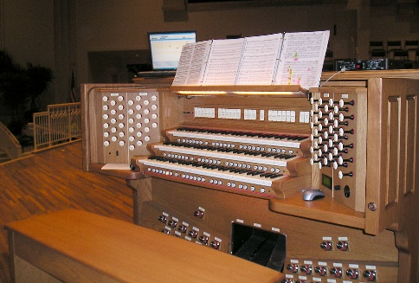
The music that you choose for your wedding should be of the quality and style which speaks of God, love, and the commitment you are pledging to one another in the midst of the Church and the assembled community. The music chosen should be scriptural in content, or based on a solid Catholic understanding of the sacrament of marriage. Songs which are “popular” in nature, or come from shows, movies, or other productions rarely bring to mind God and the sacrament of marriage. Therefore, songs like these are unacceptable and cannot be used at the Church. They can, however, make for beautiful music at the reception. The organist will guide your musical choices so that they are appropriate to the Liturgy. Cantors, especially at a Mass, are always a wise choice in order to offer the possibility of greater participation from your guests. Solos are certainly welcome, but the music should never be all solos.

If you wish to bring in a guest organist or cantor/soloist please make sure that the person is competent and willing to take the time to rehearse with the appropriate people. Extra rehearsal time may also increase the amount of the fee for the musicians. Other musicians/instrumentation are welcome but must be played from the choir loft and approved by our Director of Music.

XVIII Sacrament of Reconciliation (Confession)
It is recommended that Catholics receive this sacrament before their wedding. As a sacrament, marriage should be celebrated in the state of grace. The Church teaches us that persons should be without sin at the time of the marriage if they are to receive the special grace of the sacrament, along with the spiritual help needed to live happily in the married state.

XIX Parish Registration after the Wedding
Newly married couples must register as a new family within the parish. Take a few minutes to call and register, whether it be here at our parish or at the parish in which you will reside after the wedding. If you and your spouse intend to stay at Saint Joseph the Worker you must register as a married couple. This will not automatically be done for you. If you fail to do so it can be problematic in the future (e.g. for a child’s baptism). It’s much easier, and smarter, to take care of your parish registration as soon as you possibly can.

THANK YOU FOR YOUR ATTENTION TO THESE IMPORTANT MATTERS.
PLEASE HOLD ON TO THIS BOOKLET UNTIL AFTER YOUR WEDDING DAY.
IT WILL ANSWER MANY OF YOUR QUESTIONS.

(First Edition -March 2022)

